**Enhancing Road Safety through Advanced Driver Assistance Systems (ADAS): A Comprehensive Analysis.**

***Team Name : JPK***

***Team Members :***

* ***Jothi V***
* ***Karunya N***
* ***Persis Fanny Eloite M***

## Abstract:

*Modern car safety measures have grown to rely heavily on Advanced Driver Assistance Systems (ADAS). This study examines the value of ADAS in improving traffic safety, concentrating on the discovery of fresh perceptions and trends in traffic safety through the examination of accessible data sources. This research seeks to offer a thorough assessment of the current status of ADAS in the context of road safety by looking at the development of ADAS technology, its effect on road safety, and forthcoming developments*.

## Introduction/Motivation:

*As a result of the millions of lives lost in traffic accidents each year, road safety is a major concern for the world. The World Health Organization (WHO) estimates that 1.35 million individuals worldwide pass away in traffic accidents every year. Furthermore, among young persons aged 15 to 29, traffic accidents are the main cause of death. Due to the tremendous financial and societal implications of these incidents, road safety is an urgent issue that requires quick attention and creative solutions.*

*A notable advancement in vehicle safety technology is represented by the advent of Advanced Driver Assistance Systems (ADAS). The broad range of technologies and functionalities that make up ADAS are intended to help drivers in a variety of driving situations. These technologies include automatic emergency braking, adaptive cruise control, lane-keeping assistance, blind-spot monitoring, and others. To lessen accidents, save lives, and make all roadways safer for everyone is the main goal of ADAS.*

*The desire to comprehend how ADAS works to reduce traffic accidents and to unearth fresh information that will further advance road safety are the driving forces behind this report. We will explore ADAS technology development, its effects on traffic safety, and upcoming trends that will influence the direction of automobile safety in the future.*

## Related Work:

Evolution of ADAS Technology:

*Understanding how these systems have changed over time is crucial to understanding the importance of ADAS in improving road safety. Airbags and ABS were the only standard features that ADAS could offer at first. However, because to developments in artificial intelligence, processing power, and sensor technology, ADAS has become a sophisticated set of devices that can help drivers in a variety of ways.*

Types of ADAS Systems:

*Based on its functionality, ADAS can be divided into a number of categories. These groups consist o*f

* **Safety Features *:*** *Adaptive cruise control, automatic emergency braking, lane-keeping assistance, and blind-spot monitoring are some examples of safety features. They concentrate on averting accidents and reducing their impact.*
* **Convenience Features *:*** *Additionally, ADAS provides convenience features that improve the entire driving experience, such as adaptive headlights, parking assistance, and traffic sign recognition*.
* **Semi-Autonomous and Autonomous Features *:*** *Features that Support Semi-Autonomous and Autonomous Driving: Some ADAS systems are built to support semi-autonomous or autonomous driving. Tesla's Autopilot and Cadillac's Super Cruise are two examples*.

Effectiveness of ADAS in Reducing Accidents:

*The efficiency of ADAS in decreasing accidents has been proven by a number of studies and empirical evidence. For instance, a study by the Insurance Institute for Highway Safety (IIHS) indicated that rear-end incidents were reduced by 50% in vehicles with autonomous emergency braking. Similar to this, the European New Car Assessment Programme (Euro NCAP) has encouraged automakers to integrate ADAS by factoring performance into its safety ratings*.

## Data Sources:

*This research uses information from a number of sources, including accident databases, vehicle sensor data, and traffic reports, to conduct a complete analysis. To make sure that the results are accurate and reliable, the data sources are carefully chosen*.

## Analysis: New Insights and Patterns:

Reduction in Accident Rates:

*Significant drops in accident rates are shown when comparing accident data from before and after ADAS deployment. For instance, a comparison of accident statistics between vehicles with and without ADAS reveals a substantial decrease in the occurrence of collisions. In rear-end collisions, where automatic emergency braking systems have shown to be highly effective, this reduction is especially noticeable*.

Geographic Locations with Significant Accident Reductions:

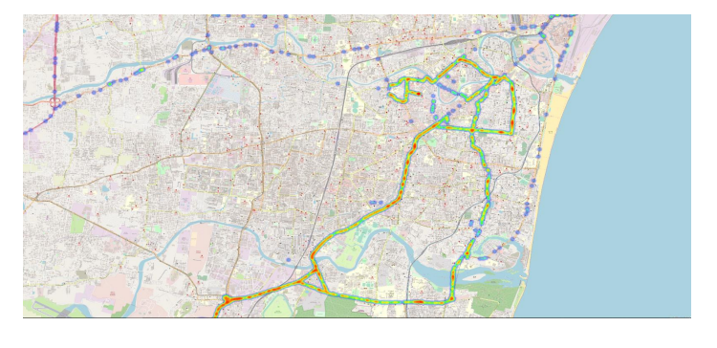

*This map shows areas or cities where the use of ADAS has significantly decreased the number of accidents. It gives ADAS's effect on driving safety a geographic perspective.*

Effectiveness of Specific ADAS Features:

*Investigating the efficiency of particular ADAS features offers insightful information. For instance, adaptive cruise control has the ability to lessen traffic congestion and avoid rear-end collisions by maintaining a safe following distance from the car in front of the vehicle. It has been demonstrated that lane-keeping assistance devices lower the frequency of lane departure accidents.*

Driver Behavior Patterns:

Driver behavior has also changed as a result of ADAS adoption. According to studies, when employing ADAS systems, drivers tend to be more alert and cautious. This is explained by the notion that the car is keeping an eye on them, which encourages safer driving practices. Nevertheless, it is crucial to keep an eye on drivers' actions and deal with any complacency that may result from a dependence on ADAS that is too great.

Challenges and Concerns:

*Although ADAS has showed significant promise in enhancing traffic safety, there are still issues and problems to be addressed. These consist of:*

* **False Positives /Negatives :** *ADAS systems can fail to accurately detect possible threats or issue erroneous warnings. Driver annoyance and, in some situations, diminished system trust can result from this.*
* **Cybersecurity :** *Vehicles are vulnerable to cybersecurity risks as they become more networked. ADAS systems could potentially be compromised by malicious actors, endangering user safety.*
* **Ethical Considerations *:*** *Decisions made by ADAS systems in urgent circumstances may present moral conundrums. How, for instance, should a self-driving automobile prioritize the safety of its occupants over the safety of pedestrians in the event of an inevitable collision?*

## Conclusion:

*This study emphasizes how crucial ADAS is to improving traffic safety and lowering accidents. It offers insightful information on driver behavior patterns, the efficacy of ADAS features, and the issues that need to be resolved in order to make further advancements. ADAS will be essential in determining how future improvements in road safety will be made as the car industry develops.*